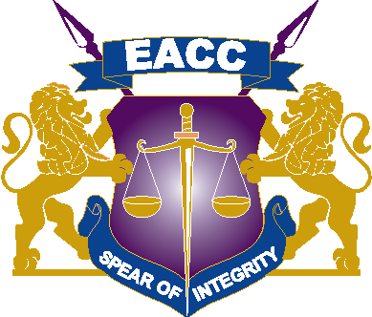

18th October, 2021

ADDENDUM ONE OF TENDER NO: EACC/T/14/2021-2022
IFMIS NO. 896389, TENDER FOR SUPPLY, INSTALLATION, TESTING, COMMISSIONING OF STANDBY GENERATOR IN EACC’s SOUTH NYANZA REGION -KISII

Reference is made to the above Open Tender – Reserved for Women owned enterprises

Kindly note that the Tender is open to all the reserved groups (AGPO); Youth, Women and People living With Disabilities owned enterprises registered with the National Treasury.
Kindly note that the closing date for the above referenced tender has been extended from 26th October, 2021 to 29th October, 2021 at 10.00 Am
Bidders to note changes/additions under Section II – Tender Data Sheet ITT 7.1 as per the attached document;
A Site visit will be held at EACC Kisii Regional office and is scheduled to Take place on 19th October,2021 from 9.00Am – 5.00 pm and Suppliers will be required to sign the Site visit register. This is an optional site visit for interested bidders.
Note that the site visit date has been changed and scheduled to take place on 22nd October, 2021 from 9.00 Am – 5.00 Pm and Suppliers will be required to sign the Site visit register. This is an optional site visit for interested bidders.

For further enquiries and Communication use the below communication channel.

eacc@integrity.go.ke or supply-chain@integrity.go.ke
Phone: 0709781000
:0730997000

