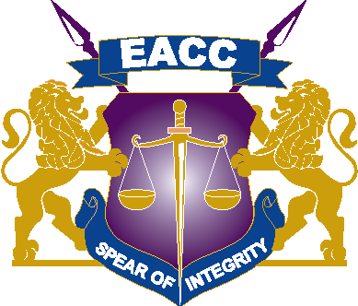

TENDER NUMBER EACC/T/24/2021-2022
IFMIS NEGOTIATION NO:916493

TENDER FOR PROPOSED FACE LIFTING OF EACC’S
INTEGRITY CENTER HOUSE

PHASE 1
(External Walling, Decking and Partitioning of the 4th floor, together with the related electrical and mechanical works and associated works)

ADDENDUM ONE
18th January 2022

In accordance with the “Tender for Proposed Face Lifting of EACC’s Integrity Centre House”, EACC Hereby issues Addendum No 1

SECTION III - EVALUATION AND QUALIFICATION CRITERIA

PRELIMINARY EXAMINATION
The item below shall be deleted from the list of mandatory requirement requested in the tender document.
MR 19 | Mandatory Site Visit Certificate | Copy of the document scanned in IFMIS

PRIME COSTS AND PROVISIONAL SUMS

ITEM | DESCRIPTION | AMOUNT
A  B  C  D  E  F | Prime cost sum for:  Allow a Prime cost sum of Kenya Shillings Fifteen Million Eight hundrend thousand only (Ksh. 15,800,000.00) for 2.No Scenic Passenger Lift  Allow for main contractor’s profit and overheads (--------%)  Allow for attendants (--------%)  Allow a Prime cost sum of Kenya Shillings Twenty Million (Ksh. 20,000,000.00) only for modular centre and relocation of the main server room to basement  Allow for main contractor’s profit and overheads (--------%)  Allow for attendants (--------%) | 15,800,000  20,000,000

Acknowledgement of Addendum No 1
We, the undersigned hereby certify that the addendum is an integral part of the document and the alterations set out in addendum has been incorporated in the tender document

Tenderer:………………………………………………………………………….

Signed:……………………………………………………………………………….

Dated:………………………………………………………………………………..

