RESTRICTED TENDER NOTICE

ETHICS AND ANTI- CORRUPTION COMMISSION

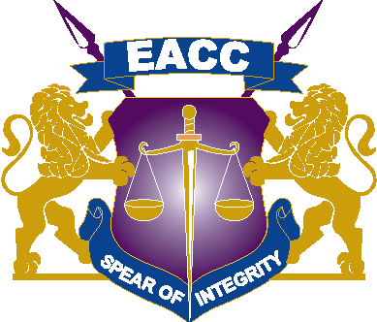

NOTIFICATION OF INTENTION TO PROCURE FORENSIC EQUIPMENT LICENSES AND TOOLS THROUGH RESTRICTED TENDERING METHOD.

NOTIFICATION DATE OF 21st JANUARY, 2022

THE COMMISSION INTENDS TO PROCURE FORENSIC EQUIPMENT LICENSES AND TOOLS THROUGH A RESTRICTED TENDER.

INTERESTED SUPPLIERS WHO ARE ELIGIBLE, LICENSED AND DISTRIBUTORS IN KENYA ARE ADVISED TO REGISTER.

THE MINIMUM PRELIMINARY REQUIREMENTS ARE AS FOLLOWS:

- Proof of Previous experience in supply and delivery and/or renewal of Forensic tools Licenses.

- Bidders must provide Distributors letter from the Manufacturers for the Licenses

- Must be registered with IFMIS

Bidders who meet the above criteria are requested to Submit their Company Profile and contacts through supply-chain@integrity.go.ke

CLOSING DATE: 25TH JANUARY 2022 at 10:00 A.M

