RESTRICTED TENDER NOTICE

ETHICS AND ANTI- CORRUPTION COMMISSION

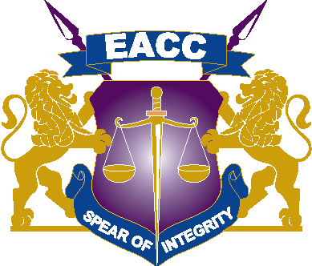

NOTIFICATION OF INTENTION TO PROCURE EXECUTIVE CATERING THROUGH RESTRICTED TENDERING METHOD.

NOTIFICATION OF 12th AUGUST, 2022

THE COMMISSION INTENDS TO PROCURE EXECUTIVE CATERING SERVICES THROUGH A RESTRICTED TENDER.

INTERESTED SERVICE PROVIDERS WHO ARE ELIGIBLE AND ARE 3 STAR AND ABOVE ARE ADVISED TO REGISTER.

THE MINIMUM PRELIMINARY REQUIREMENTS ARE AS FOLLOWS:
- Bidders must provide company registration/incorporation certificate
- Bidders must provide valid Tax Compliance Certificate
- Bidders must provide Current levy certificate
- Medical certificate of food handlers for at least 2 chefs & 3 support staff.
- Certificate of compliance to public health requirements.
- Indicate minimum time of delivery
- Bidders Must NOT be more than 2 Km away from the EACC offices.

Bidders who meet the above criteria are requested to Submit their Company Profile and contacts through supply-chain@integrity.go.ke or pbett@integrity.go.ke

CLOSING DATE: 17th August 2022 at 10:00 A.M

