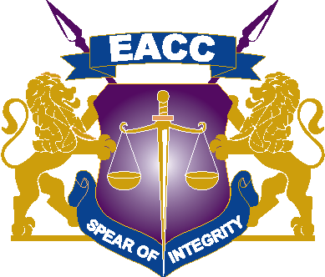

SCHEDULE OF RESPONSIBLE COMMISSIONS AND PUBLIC ENTITIES TO WHICH STATE AND PUBLIC OFFICERS SHOULD SUBMIT DECLARATIONS

 | State/Public Office | Responsible Commission
1. | Attorney General  Cabinet Secretaries  Secretary to the Cabinet  Solicitor General  Principal Secretaries  Accounting Officers who are State Officers | Submit to the Chief of Staff and Head of Public Service (pending review of the law to prescribe the appropriate responsible commissions for the offices)
2. | Officials of registered Savings and Credit Cooperative Societies (SACCOS) | Ethics Commission for Co-operative Societies (ECCOs)
3. | State and Public officers in the County Governments | The respective County Public Service Board, County Assembly Service Board or County Assembly Powers and Privileges Committee
4. | Public officers for whom there is no prescribed Responsible Commission | Public Service Commission (Pursuant to Regulation 9 of the Public Officer Ethics Regulations, 2003)

