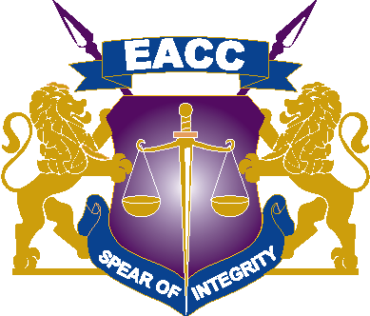

11TH FEBRUARY, 2026
ADDENDUM ONE
SUPPLY AND DELIVERY OF BOTTLED OFFICE DRINKING WATER AND DISPENSER SERVICES UNDER A FRAMEWORK CONTRACT NO: EACC/T/10/2025-2026.
Reference is made to the above cited procurement.
Kindly take note of the following change
Mandatory Requirement.

MR.6 Must provide valid Certification of Water Plant & processes by KEBS or a Distributor must attach the certification of the Firm

The aim of the addendum is to waive mandatory no.6 as a mandatory requirement.

Acknowledgement of Addendum No 1
We, the undersigned hereby certify that the addendum is an integral part of the document and the alterations set out in addendum have been incorporated in the tender document.
Tenderer:…………………………………………………………………………….
Signed:……………………………………………………………………………….
Dated:………………………………………………………………………………..

