RESTRICTED TENDER NOTICE

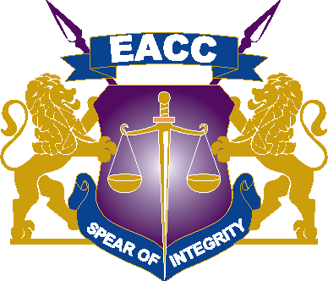
ETHICS AND ANTI- CORRUPTION COMMISSION

NOTIFICATION OF INTENTION FOR PROCUREMENT FOR SUPPLY AND DELIVERY OF OFFICE AIRTIME SCRATCH CARDS (SAFARICOM & AIRTEL)

NOTIFICATION ON 11TH SEPTEMBER, 2026.

The Commission is in the process of procuring office airtime through the restricted tendering method and has so far identified Safaricom PLC and Airtel Network Limited who are manufacturers and potential service providers.

Accordingly, eligible and interested service providers are invited to register their interest by submitting the following minimum preliminary requirements:

NO. | Requirements | Responsive or Not Responsive
MR 1 | Certificate of Registration / incorporation
MR 2 | Valid Tax Compliance Certificate from KRA.
MR 3 | A Letter of Authorization from Safaricom PLC and Airtel Network Limited, confirming authorized dealer/distributor permitted to supply their respective airtime scratch cards.
MR 4 | MUST provide their eGPS – System registration number

Bidders who meet the above criteria are requested to submit their Company Profile and the above through supply-chain@integrity.go.ke and candrew@integrity.go.ke

CLOSING DATE: 15th SEPTEMBER, 2026 at 10:00 A.M

